SIMATS ENGINEERING (SAVEETHA SCHOOL OF ENGINEERING)
Department of Computer Science and Engineering
CO3 ASSESSMENT TOOL 1 – Git & Docker Technical Assignment

Course Code: | CSA10 / CSA1063 | Course Title: | Software Engineering
CO Assessed: | CO3 | Assessment: | Assessment Tool 1 – Git & Docker Technical Assignment
Weightage: | 20% | Total Marks: | 25
CO3 Statement: | Build full-stack applications with an emphasis on containerization, version control, and collaborative development
Student Name: |  | Reg. No.:
Date: |  | Duration: | 60 minutes

Code of Conduct
I __________________________ (Name / Reg No) certify that this submission is my original work and that I have adhered to the guidelines specified for this assessment. I understand that any violation of academic integrity rules will result in disciplinary action.
Signature of the Student: _________________________
Annexure A – Git & Docker Technical Assignment
Instructions to Students:
Each student has been assigned an individual problem statement. Based on the assigned problem statement, prepare a Git & Docker Technical Assignment by applying version control and containerization concepts. Your report should include appropriate diagrams, screenshots, commands, and explanations wherever applicable.

Assignment Questions
- Problem Analysis
  - Explain the assigned problem statement and identify the project objectives, functional requirements, and expected outcomes.
- Project Structure Design
  - Design and explain the folder structure of your project repository.
  - Justify the purpose of each major folder and file included in the repository.
- Git Repository Initialization
  - Create a Git repository for the project.
  - Explain the steps involved in repository initialization and describe the purpose of the essential Git files.
- Git Branching Strategy
  - Design a suitable branching strategy (e.g., Main, Development, Feature, Release, Hotfix).
  - Justify why the selected branching model is appropriate for the assigned project.
- Version Control Workflow
  - Demonstrate the Git workflow by performing meaningful commits, branch creation, merging, conflict resolution (if applicable), and repository synchronization.
  - Explain the purpose of each Git operation performed.
- Commit History Analysis
  - Present the commit history of the project.
  - Explain how commit messages follow good version control practices and contribute to project maintenance.
- Docker Environment Design
  - Explain why Docker is suitable for the assigned project.
  - Identify the application components that require containerization.
- Dockerfile Development
  - Design and explain the Dockerfile required to containerize the application.
  - Describe the purpose of each instruction used in the Dockerfile.
- Docker Compose Design
  - Develop a Docker Compose configuration for the project.
  - Explain the services, networking, volumes, environment variables, and dependencies used.
- Container Deployment and Testing
  - Demonstrate the execution of the application using Docker containers.
  - Explain the testing procedure and provide evidence that the application runs successfully.
- Benefits of Git and Docker
  - Discuss how Git and Docker improve collaboration, version management, portability, deployment, scalability, and maintainability for your assigned project.
- Challenges and Improvements
  - Identify the challenges encountered during implementation.
  - Suggest possible improvements and future enhancements for the Git workflow and Docker deployment.

Expected Deliverables
- Technical report (10 pages)
- Git repository with complete commit history
- Source code of the assigned project
- Dockerfile
- Docker Compose file (docker-compose.yml)
- Screenshots of Git operations and Docker execution
- Architecture and workflow diagrams

Problem Statement:Intelligent Hospital Asset Tracking and Patient Flow Management Platform
1. Problem Analysis
1.1 Problem Statement
Hospitals manage a large number of critical assets such as hospital beds, wheelchairs, infusion pumps, ventilators, monitors, stretchers, and other medical equipment. In a large hospital, manually identifying the location and availability of these assets can be time-consuming and inefficient.
At the same time, patient movement through registration, consultation, diagnosis, treatment, admission, transfer, and discharge must be coordinated efficiently. Poor visibility of patient flow can result in long waiting times, overcrowded departments, inefficient bed utilization, and delays in treatment.
The Intelligent Hospital Asset Tracking and Patient Flow Management Platform is proposed as a centralized software platform that helps hospital administrators track assets and monitor patient flow. The platform provides information about asset location, availability, usage, and maintenance while also providing information about patient queues, department transfers, bed availability, and patient status.
The platform can provide a centralized dashboard for hospital staff and administrators to make faster and better operational decisions.
1.2 Project Objectives
The major objectives are:
- To track hospital assets and their current status.
- To identify whether an asset is available, assigned, in use, under maintenance, or unavailable.
- To monitor the movement of patients between hospital departments.
- To reduce patient waiting time.
- To improve utilization of hospital beds and medical equipment.
- To provide centralized information to authorized hospital staff.
- To generate alerts for important asset and patient-flow events.
- To maintain reliable records using a centralized database.
- To provide a scalable and portable application using Docker.
- To support collaborative software development using Git.
1.3 Functional Requirements
Asset Management
- Add new hospital assets.
- Update asset information.
- Delete or deactivate assets.
- Search for assets.
- View asset location.
- View asset availability.
- Assign assets to departments or patients.
- Record asset maintenance.
- Track asset status.
Patient Flow Management
- Register patients.
- Create patient flow records.
- Record patient arrival.
- Assign patients to departments.
- Track waiting status.
- Record consultation and treatment.
- Transfer patients between departments.
- Track bed allocation.
- Record patient discharge.
Dashboard
The dashboard should display:
- Total assets.
- Available assets.
- Assets currently in use.
- Assets under maintenance.
- Number of active patients.
- Department-wise patient count.
- Waiting patients.
- Available beds.
- Patient-flow alerts.
User Management
The system can support different roles:
- Administrator
- Doctor
- Nurse
- Receptionist
- Hospital staff
Each role should have appropriate permissions.
1.4 Non-Functional Requirements
The system should satisfy the following quality requirements:
Performance:
The application should provide responses within an acceptable time even when multiple users access the system.
Security:
Only authenticated and authorized users should be allowed to access sensitive hospital information.
Scalability:
The application should support additional departments, users, assets, and patients as the hospital grows.
Availability:
The system should remain available during normal hospital operations.
Maintainability:
The application should have a modular architecture so individual components can be modified without affecting the entire system.
Portability:
Docker should allow the application to run consistently across different environments.
Reliability:
Asset and patient-flow information should be stored consistently and accurately.
1.5 Expected Outcomes
The expected outcomes are:
- Faster identification of medical equipment.
- Better asset utilization.
- Reduced equipment-search time.
- Improved patient-flow visibility.
- Reduced departmental congestion.
- Improved bed utilization.
- Faster operational decision-making.
- Centralized hospital information.
- Easier deployment through Docker.
- Better collaboration through Git.

2. Project Structure Design
A suitable repository structure is:
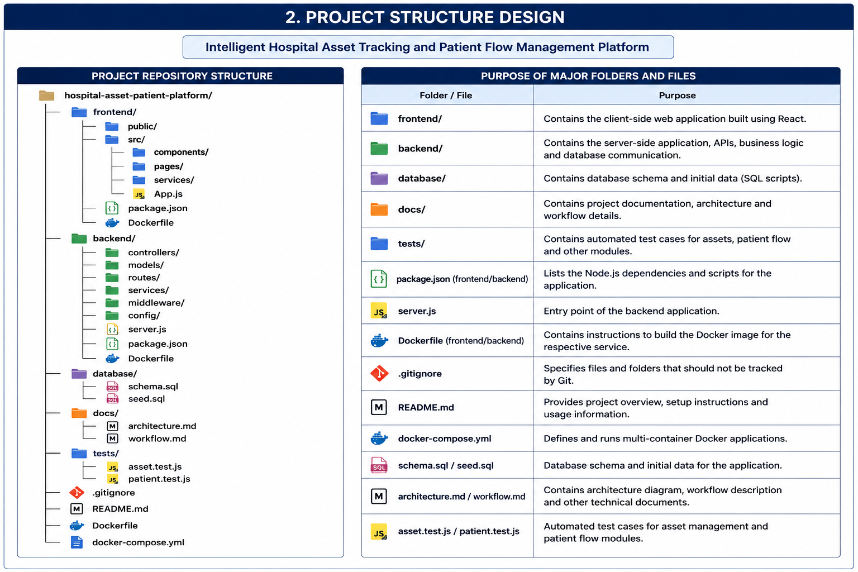
Purpose of Major Folders
frontend/
Contains the user interface of the application.
backend/
Contains server-side logic, APIs, authentication, business logic, and database communication.
database/
Contains database schema and initial data.
docs/
Contains project documentation and architecture information.
tests/
Contains automated tests for application functionality.
Dockerfile
Defines instructions for creating a Docker image.
docker-compose.yml
Defines and manages multiple application services.
.gitignore
Specifies files that should not be tracked by Git.
README.md
Contains project information, setup instructions, and usage information.
The assignment specifically requires the repository structure and justification of the purpose of major folders and files.

3. Git Repository Initialization
Git is used to maintain the source-code history and support collaborative development.
Git Initialization Steps
First, create the project directory:
mkdir hospital-asset-patient-platform
cd hospital-asset-patient-platform
Initialize Git:
git init
Check the repository:
git status
Add project files:
git add .
Create the initial commit:
git commit -m "chore: initialize hospital platform project"
Add the remote repository:
git remote add origin <repository-url>
Push the code:
git push -u origin main
Important Git Files
.git/
Stores Git repository information, including objects, references, configuration, and history.
.gitignore
Prevents unnecessary or sensitive files from being committed.
Example:
node_modules/
.env
logs/
dist/
coverage/
README.md
Provides project documentation and instructions.
The assignment requires explanation of repository initialization and the purpose of essential Git files.
4. Git Branching Strategy
A suitable branching strategy is:
main
│
└── develop
├── feature/asset-tracking
├── feature/patient-flow
├── feature/dashboard
└── feature/authentication
Main Branch
The main branch contains stable production-ready code.
Develop Branch
The develop branch contains integrated development work before a production release.
Feature Branches
Each major feature is developed independently.
Examples:
git checkout -b feature/asset-tracking
git checkout -b feature/patient-flow
git checkout -b feature/dashboard
Release Branch
A release branch can be created when the application is ready for testing:
git checkout -b release/v1.0
Hotfix Branch
Urgent production issues can be handled using:
git checkout -b hotfix/fix-asset-status
Justification
This branching strategy separates stable code from ongoing development. It allows different features to be developed independently and reduces the risk of unstable code entering the production branch.
The assignment specifically asks for a suitable branching strategy and justification.
5. Version Control Workflow
The development workflow can be:
Create Issue
↓
Create Feature Branch
↓
Develop Feature
↓
git add
↓
git commit
↓
git push
↓
Code Review
↓
Merge into Develop
↓
Testing
↓
Release
↓
Merge into Main
Example
Create a branch:
git checkout develop
git checkout -b feature/asset-tracking
Add changes:
git add .
Commit:
git commit -m "feat: add hospital asset tracking"
Push:
git push -u origin feature/asset-tracking
Merge:
git checkout develop
git merge feature/asset-tracking
Push the updated development branch:
git push origin develop
Conflict Resolution
If a merge conflict occurs:
git status
Open the conflicting files and resolve the differences.
Then:
git add .
git commit -m "fix: resolve merge conflict"
Synchronization
Before starting new work:
git pull origin develop
This ensures the local repository contains the latest development changes.
The assignment requires meaningful commits, branch creation, merging, conflict resolution where applicable, and repository synchronization.
6. Commit History Analysis
Good commit messages should clearly describe what was changed.
Example Commit History
chore: initialize project repository
feat: add asset management module
feat: add patient registration module
feat: implement patient flow tracking
feat: add hospital dashboard
feat: add asset status API
fix: correct patient transfer validation
fix: resolve asset availability issue
docs: update project documentation
test: add asset tracking tests
build: add Docker configuration
Good Commit Practices
Commit messages should:
- Be short and meaningful.
- Describe one logical change.
- Use consistent naming.
- Avoid vague messages such as changes, update, or final.
- Make project history easier to understand.
For example:
feat: implement asset location tracking
is better than:
updated code
A meaningful history helps developers identify when features were introduced and when problems were fixed.
The assignment specifically evaluates meaningful commits, professional commit messages, and clear commit history.
7. Docker Environment Design
Docker is suitable because the platform contains multiple components that need to operate together.
Components to Containerize
Frontend
│
↓
Backend API
│
↓
Database
The system can use three primary containers:
- Frontend container
- Backend container
- Database container
Benefits of Docker
Docker provides:
- Consistent development environments.
- Easy application deployment.
- Portability.
- Isolation between services.
- Easier dependency management.
- Simplified application startup.
- Reproducible environments.
- Easier scaling.
The assignment explicitly asks why Docker is suitable and which application components require containerization.
8. Dockerfile Development
A Dockerfile defines how an application image is built.
Example Backend Dockerfile
FROM node:20-alpine
WORKDIR /app
COPY package*.json ./
RUN npm install
COPY . .
EXPOSE 5000
CMD ["npm", "start"]
Explanation
FROM
FROM node:20-alpine
Uses Node.js as the base image.
WORKDIR
WORKDIR /app
Sets the application working directory.
COPY
COPY package*.json ./
Copies package configuration files.
RUN
RUN npm install
Installs application dependencies.
COPY
COPY . .
Copies source code into the image.
EXPOSE
EXPOSE 5000
Documents the port used by the application.
CMD
CMD ["npm", "start"]
Starts the application.
The assignment requires both the Dockerfile design and explanation of each Dockerfile instruction.
9. Docker Compose Design
Docker Compose can manage the frontend, backend, and database together.
docker-compose.yml
services:
frontend:
build: ./frontend
ports:
- "3000:3000"
depends_on:
- backend
backend:
build: ./backend
ports:
- "5000:5000"
environment:
DB_HOST: database
DB_PORT: 5432
DB_NAME: hospitaldb
DB_USER: hospitaluser
DB_PASSWORD: hospitalpass
depends_on:
- database
database:
image: postgres:16
environment:
POSTGRES_DB: hospitaldb
POSTGRES_USER: hospitaluser
POSTGRES_PASSWORD: hospitalpass
volumes:
- hospital_data:/var/lib/postgresql/data
ports:
- "5432:5432"
volumes:
hospital_data:
Services
frontend
Runs the user interface.
backend
Runs APIs and business logic.
database
Stores application data.
Networking
Docker Compose creates a network that allows services to communicate using their service names.
For example, the backend can connect to:
database:5432
rather than using localhost.
Volumes
The database uses:
hospital_data:/var/lib/postgresql/data
to preserve database information.
Environment Variables
Database configuration is passed through environment variables.
Dependencies
The backend depends on the database, while the frontend depends on the backend.
The assignment specifically requires explanation of services, networking, volumes, environment variables, and dependencies.

10. Container Deployment and Testing
Build the Containers
docker compose build
Start the Application
docker compose up -d
Check Running Containers
docker compose ps
View Logs
docker compose logs
Backend logs:
docker compose logs backend
Stop the Application
docker compose down
Test the Application
The following tests can be performed:
Test 1 – Frontend
Open:
http://localhost:3000
Expected result:
The hospital dashboard should be displayed.
Test 2 – Backend
Open the appropriate API endpoint, for example:
http://localhost:5000/api/health
Expected result:
{
"status": "OK"
}
Test 3 – Database
Verify that the backend successfully connects to the database.
Test 4 – Asset Management
Add an asset and verify that it appears in the asset list.
Test 5 – Patient Flow
Register a patient and verify that the patient appears in the appropriate department/queue.
Test 6 – Container Status
Run:
docker compose ps
All required services should be running.
Evidence/Screenshots
The report should include screenshots of:
- git status
- git log
- Branch creation
- Git merge
- Docker image build
- docker compose up
- Running containers
- Application dashboard
- Asset tracking screen
- Patient-flow screen
The assignment requires evidence that the application has been successfully deployed and tested.
11. Benefits of Git and Docker
Benefits of Git
Collaboration
Git allows multiple developers to work on different features using branches.
Version Management
Every commit provides a history of project changes.
Error Recovery
Previous versions can be restored when necessary.
Branching
Developers can work on features without directly modifying stable code.
Code Review
Feature branches can be reviewed before merging.
Benefits of Docker
Portability
The same container configuration can be used across development and deployment environments.
Consistency
Docker reduces differences between developer machines.
Deployment
The complete application can be started using Docker Compose.
Isolation
Different services operate in separate containers.
Scalability
Individual services can be scaled according to requirements.
Maintainability
Each service can be maintained independently.
The assignment specifically expects discussion of collaboration, version management, portability, deployment, scalability, and maintainability.
12. Challenges and Improvements
12.1 Challenges
Challenge 1 – Asset Location Accuracy
Maintaining accurate asset-location information can be difficult, especially when assets are moved between departments.
Challenge 2 – Patient Flow Complexity
Patients may move between several departments, making the flow difficult to represent.
Challenge 3 – Data Security
Hospital systems handle sensitive information, so authentication and authorization are important.
Challenge 4 – Database Availability
The application depends on reliable database access.
Challenge 5 – Docker Configuration
Incorrect ports, environment variables, dependencies, or networking can prevent services from communicating.
Challenge 6 – Git Merge Conflicts
Multiple developers modifying the same files can create merge conflicts.
Challenge 7 – Real-Time Updates
Maintaining real-time asset and patient-flow information can increase system complexity.
12.2 Improvements
Future versions can include:
- RFID-based asset identification.
- BLE-based indoor asset tracking.
- Real-time dashboard updates.
- Mobile applications for hospital staff.
- AI-based patient-flow prediction.
- Equipment-demand prediction.
- Automated alerts.
- Advanced analytics.
- Role-based access control.
- Audit logging.
- Automated CI/CD pipelines.
- Automated Docker image deployment.
- Cloud deployment.
- Database backup and recovery.
- Monitoring and logging systems.
12.3 Future Intelligent Features
An advanced version could analyze historical patient-flow data and identify departments where waiting times are increasing.
Similarly, asset utilization data could be analyzed to determine which equipment is frequently used and which equipment remains underutilized.
This could help hospital administrators improve resource allocation and operational planning.
Architecture Diagram
The proposed system architecture is:
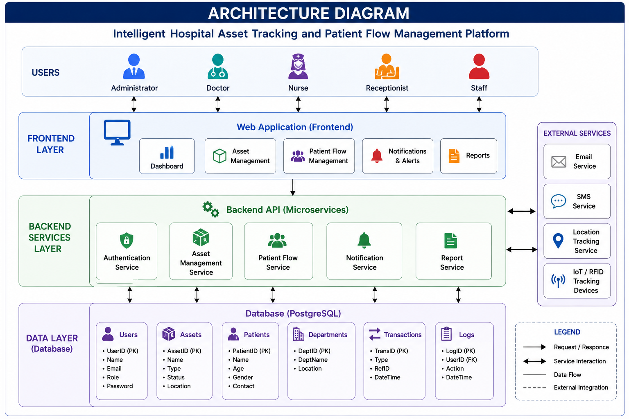
Overall Workflow
Patient Registration
↓
Patient Queue
↓
Department Assignment
↓
Consultation / Treatment
↓
Transfer if Required
↓
Bed Allocation
↓
Treatment Completion
↓
Discharge
At the same time:
Asset Registration
↓
Asset Location
↓
Asset Allocation
↓
Asset Usage
↓
Asset Return
↓
Maintenance
↓
Available Again

Conclusion
The Intelligent Hospital Asset Tracking and Patient Flow Management Platform provides a centralized solution for managing hospital resources and monitoring patient movement. The proposed architecture separates the frontend, backend, tracking functionality, and database, making the system easier to maintain and extend.Git provides version control, branching, collaboration, and reliable project history, while Docker provides portability, consistent environments, service isolation, and simplified deployment. Together, Git and Docker support the software-engineering objectives of the project.The project can be further enhanced using IoT-based tracking, real-time notifications, analytics, artificial intelligence, mobile applications, cloud deployment, and CI/CD automation.For the submitted technical assignment, the implementation should include the Git repository, complete commit history, source code,and Dockerfile.
Rubrics for Calculation
Evaluation Criteria | Excellent (4 Marks) | Good (3 Marks) | Satisfactory (2 Marks) | Needs Improvement (1 Mark)
Problem Analysis & Project Design(20%) | Clearly explains the problem statement, objectives, requirements, expected outcomes, and well-organized project structure with proper justification. | Good analysis and project structure with minor omissions. | Basic analysis and repository structure with limited justification. | Incomplete or unclear analysis and project organization.
Git Repository & Branching Strategy(20%) | Repository initialized correctly with appropriate branching strategy, clear workflow, and proper repository organization. | Repository and branching strategy are mostly correct. | Basic Git setup with limited branching implementation. | Incorrect or incomplete Git repository and branching strategy.
Version Control Workflow & Commit History(10%) | Demonstrates meaningful commits, branching, merging, synchronization, conflict resolution, and professional commit messages with clear history. | Most Git operations demonstrated correctly with good commit history. | Limited Git workflow and commit practices. | Poor workflow and inadequate commit history.
Docker Implementation(20%) | Well-designed Docker environment, Dockerfile, and Docker Compose configuration with clear explanation of services, networking, volumes, and dependencies. | Functional Docker implementation with minor issues. | Basic Docker implementation with limited explanation. | Incomplete or incorrect Docker implementation.
Deployment, Testing & Results(15%) | Application successfully deployed and tested with appropriate screenshots and evidence of successful execution. | Deployment completed with minor issues. | Partial deployment and testing demonstrated. | Deployment unsuccessful or insufficient evidence.
Documentation, Challenges & Future Enhancements(15%) | Professional report (10–15 pages) with diagrams, screenshots, references, discussion of benefits, challenges, and future improvements. | Good documentation with minor omissions. | Basic documentation with limited discussion. | Poor documentation and insufficient analysis.

Criteria | Mark
System Requirement Analysis (30%) | /5
Selection of Software Architecture (25%) | /5
Architecture Diagram and Component Design (20%) | /5
Component Interaction and Quality Attribute Analysis (15%) | /5
Architectural Justification and Technical Presentation (10%) | /5
TOTAL | /25

